SCAVENGER HUNT 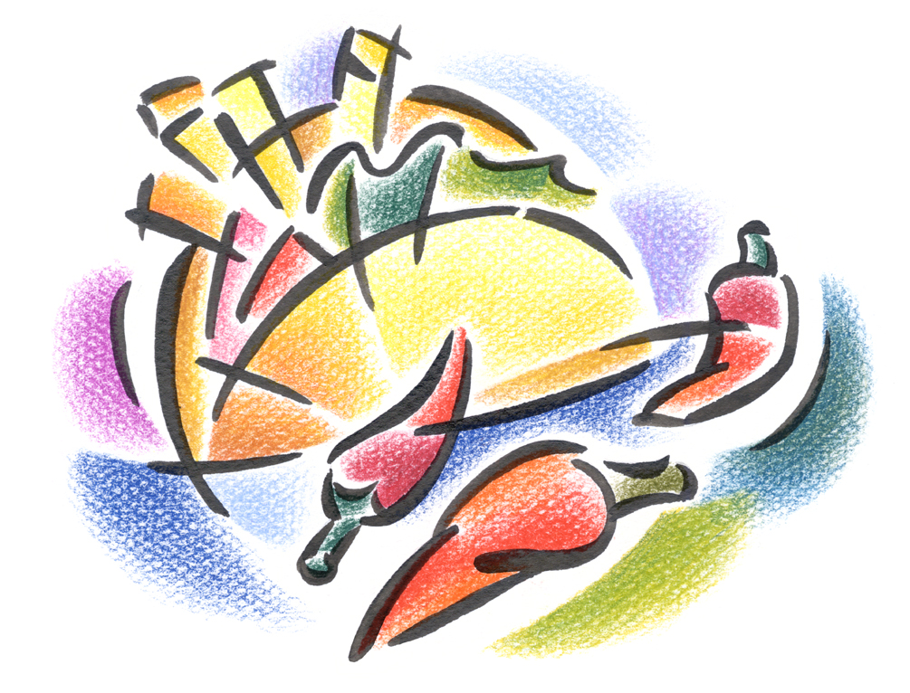

- PEACH
- LEMON
- BOTTLED ORANGE JUICE
- RED NAPKINS
- BOX OF CHOCOLATE CEREALS
- WHITE CHOCOLATE BAR
- 3 CUCUMBERS
- PLASTIC KNIVES
- FRENCH ONIONS
- SPANISH RED WINE
- STRAWBERRY ICE-CREAM
- CHICKEN BREAST

